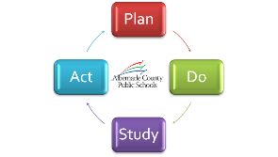
ACPS School Board Business Meeting July 10, 2014
Board Priorities Progress Assessment end of Year One
mins | Process Step | Notes
10 | Activity Overview  Desired outcome of meeting  Review Responses | Questions to answer for each Priority  - What does a 5 look like?  - Does a priority need to be adjusted or combined with another for efficiency?  - Should we abandon / postpone a priority?  - Has the priority been operationalized?
30 | Break Out Groups by Strategic Objective  Staff to answer clarifying questions.  - / 2.0 – Billy & Debbie  - / 4.0 / 5.0 – Pam & Matt
40 | Consensus Score  - Board members report out from break out groups  - Board comes to consensus on final score for each priority  - Board determines what priorities should be adjusted, adopted, abandoned.
10 | Wrap Up / Next Steps

